ST. XAVIER’S COLLEGE

**(Affiliated to Tribhuvan University)**

Maitighar, Kathmandu



**Computer Graphics Lab Assignment #8**

**Submitted by:**

Bishal Pandey

013BSCCSIT016

**Submitted to:**

|  |  |
| --- | --- |
| Er. Anil Sah  Lecturer, St. Xavier’s College |  |

**STATEMENT**

“Reflect any user given image about X axis and Y axis using C++ Builder”.

**Source code:**

**//---------------------------------------------------------------------------**

**#include <vcl\vcl.h>**

**#pragma hdrstop**

**#include "Unit1.h"**

**#include "math.h"**

**//---------------------------------------------------------------------------**

**#pragma resource "*.dfm"**

**int a, b, i, j, x, y;**

**TForm1 *Form1;**

**//---------------------------------------------------------------------------**

**__fastcall TForm1::TForm1(TComponent* Owner)**

**: TForm(Owner)**

**{**

**}**

**//---------------------------------------------------------------------------**

**void __fastcall TForm1::Reflection_originClick(TObject *Sender)**

**{**

**x = Image1->Height;**

**y = Image1->Width;**

**for(i=0;i<=x;i++)**

**{**

**for(j=0;j<=y;j++)**

**{**

**a = -i;**

**b = -j;**

**a=a+x;**

**b=b+y;**

**Image2->Canvas->Pixels[a][b] = Image1->Canvas->Pixels[i][j];**

**}**

**}**

**}**

**//---------------------------------------------------------------------------**

**void __fastcall TForm1::Reflection_xClick(TObject *Sender)**

**{**

**x = Image1->Height;**

**y = Image1->Width;**

**for(i=0;i<=x;i++)**

**{**

**for(j=0;j<=y;j++)**

**{**

**a = i;**

**b = -j;**

**b=b+y;**

**Image2->Canvas->Pixels[a][b] = Image1->Canvas->Pixels[i][j];**

**}**

**}**

**}**

**//---------------------------------------------------------------------------**

**void __fastcall TForm1::Reflection_yClick(TObject *Sender)**

**{**

**x = Image1->Height;**

**y = Image1->Width;**

**for(i=0;i<=x;i++)**

**{**

**for(j=0;j<=y;j++)**

**{**

**a = -i;**

**b = j;**

**a=a+x;**

**Image2->Canvas->Pixels[a][b] = Image1->Canvas->Pixels[i][j];**

**}**

**}**

**}**

**//--------------------------------------------------------------------**

**Outputs:**

**Reflection about origin:**

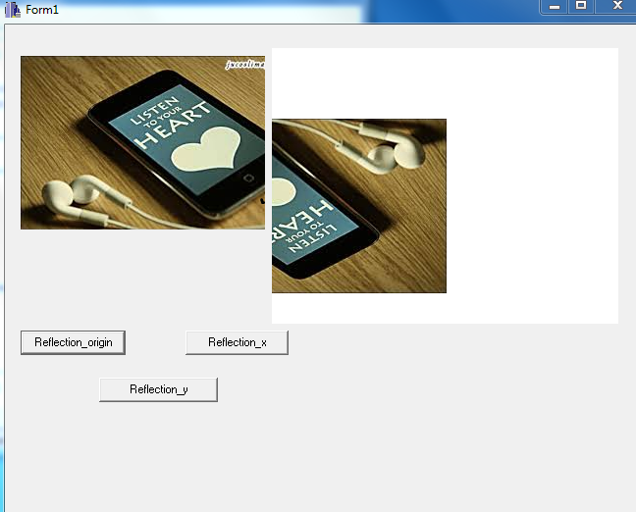

Reflection about x axis

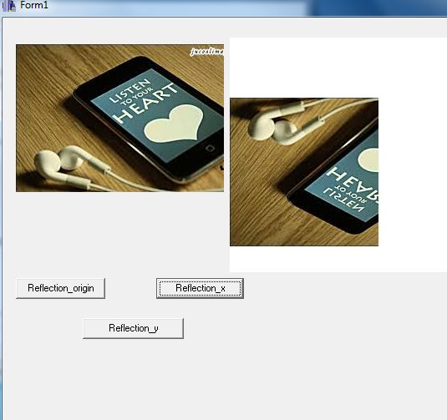

Reflection about y axis:

